**SYSTEM**

Practicum 1

**Basic Operating System**

# Nama : Fitri Cahyaniati

# Class : SIB 1G

# OVERVIEW:

* Basic on Operating System
* VMWare installation on SO
* Operating System Installation

# LEARNING OBJECTIVES:

After studying the material in this chapter, students are expected to be able to:

* Basic knowledge of operating systems, types of operating systems
* VMWare Installation on Operating System
* Know and use Windows and Linux operating systems

# THEORY BASICS:

The operating system is a program that acts as an intermediary between the user and the computer hardware. The operating system is used to execute user programs and facilitate solving user problems. In addition, the operating system makes the computer system comfortable to use.

In general, the operating system is the first layer of software that is placed in the computer's memory when the computer boots up. While other software is run after the operating system runs, and the operating system will perform core services for the software. The operating system has systematic scheduling that includes calculations of memory usage, data processing, data storage, and other resources.

Examples of modern operating systems are Linux, Android, iOS, Mac OS X, and Microsoft Windows.

**SYSTEM**

Operating System Functions

The operating system has an important role in a computer system. Here are some functions of the operating system:

* Computer Resource Management

The operating system can manage the time an application is running, share CPU usage when applications are running simultaneously, provide access to disks, and so on.

* Serves as the Basic Application of a Device

The Operating System is the basis for the formation of programs on a device. It can be said that this is a vital part that organizes all the things needed to carry out the functions of a device.

* Connecting Hardware

The operating system plays a role in coordinating all the interconnecteddevices on the gadget at the same time, such as internal storage, mouse, speakers, and CPU. In this case, the operating system acts as a bridge that connects the hardware with the software. It will then in turn run the basic operations of the computer.

* Optimizing the Function of a Device

The Operating System is able to optimize the performance of hardware and software, the system regulates and controls the relationship between hardware and software so that they can work together properly,

* Setting the Device Working System

The Operating System organizes and controls all hardware functions used, starting from the CPU, Hard Drive, memory and so on. Of course, with the operating system, all devices can work together and form a unity to maximize the function of a device.

Types of Computer Operating Systems

There are several types of computer operating systems that are quite well known. Here are some types of operating systems that run on computers:

* Stand Alone Operating System

The Stand Alone Operating System can be used by single users or multi users, this operating system also has features that are quite complete and can stand alone. Examples of stand alone operating systems are Microsoft Windows, Linux, and Mac OS.

Live CD Operating System

Live CD only requires a CD/DVD room device without the need to permanently install on the computer to run it. This operating system is very lightweight because of its small size. But the live CD operating system does not have many features compared to the stand alone operating system. Here are examples of live CD operating systems namely Knoppix, Centos, Linux Mint, Win XP live CD and others.

* Embedded Operating System

This system is directly embedded in the computer and cannot stand alone, has special functions and special specifications. Examples of Embedded Operating Systems are eCOS, LynxOS, JavaOS and Embedded Linux.

* Network Operating System

This type of operating system is made specifically to handle computer network needs. Some of the services that can be handled by network operating systems are HTTP Service, DNS Service, Printer Sharing, Proxy Server, and many more. Some examples of network operating systems areRed Hat, Centos Server, Cloud Linux and so on.

There are various operating systems and fractions of operating systems that we have listed in the following table:

|  |  |  |
| --- | --- | --- |
| No. | Operating System | Developer |
| 1 | Android | Google |
| 2 | AmigaOS | Commodore |
| 3 | AIX and AIXL | IBM |
| 4 | Chrome OS | Google |
| 5 | Corel Linux | Corel |
| 6 | iOS | Apple |
| 7 | Mac OS | Apple |
| 8 | MS-DOS 1-6.x | Microsoft |
| 9 | NEXSTEP | Apple |
| 10 | OS/2 | IBM |
| 11 | Symbian | Nokia |
| 12 | Microsoft Windows | Microsoft |
| 13 | Windows Phone | Microsoft |

|  |  |  |
| --- | --- | --- |
| 14 | UNIX | Bell Labs |
| 15 | Linux | Linus Torvald |

# PRELIMINARY TASKS:

Answer the questions below:

1. What is a Virtual Machine?

A Virtual Machine (VM) is an emulation or replica of a physical computer that runs on existing physical hardware.Name the types of Operating System and their

1. advantages and disadvantages?
2. The advantages are that Windows is user friendly because it has an interface, the installation process is much easier, Windows really supports drivers, there are lots of companies that make software and applications which are compatible with Windows, because almost everyone uses the Windows operating system, and Windows has developed very quickly.
3. The disadvantage is that it doesn't have open source, you need to buy it because it is closed source, it is very easy to hack because the security system is still quite weak, you need to buy an application that is vulnerable to viruses first, if it doesn't have built-in software.
4. List the advantages of Windows and Linux OS
5. Linux advantages :
   * + - Open Source
       - Superior in Security
       - Linux is smaller in size than Windows
       - Various options in Linux
6. Windows advantages :

* Easy Installation
* Easier or User Friendly Operation
* Rich in Features and Applications
* Support with various computer network hardware

1. Name and explain the steps taken by a computer when it first starts up!

Steps performed by the computer when it first starts:

1. Power On

2. POST (Power-On Self-Test): The computer checks and initializes hardware such as RAM, CPU, and graphics card.

3. Hardware Initialization: The computer activates hardware devices such as keyboard, mouse, and monitor.

4. Boot Device Selection: The computer searches for a storage device that contains the operating system.

5. Bootloader Process: The bootloader is loaded from the storage device and loads the operating system into memory.

6. Load the Operating System

7. Initialize Operating System

8. Login Screen or Desktop Display

1. Describe the types of software that you are familiar with!

Describe the types :

* Firmware
* Freeware
* Adware
* Opensource
* Malware
* Shareware
* Spyware

1. Explain what an operating system is!

Sistem operasi adalah perangkat lunak yang paling penting untuk menjalankan komputer.

1. Name the operating systems you know and explain them!
2. Windows ia an operating system developed by the Microsoft Corporation company
3. Linux is an open source operating system. Linux has had a significant impact in the world of computing, and is used in a variety of environments, from mobile devices and servers to embedded systems and supercomputers.
4. Android is the operating system used on smartphones. Apart from that, other devices such as TV set boxes also use the Android operating system. Android is open source, so anyone can develop it.
5. Mac is an operating system for computers and laptops under the Apple brand. From the user's perspective, Mac is an operating system with an elegant user interface. The price of the device is relatively more expensive than others.
6. In terms of software, Mac is not inferior to Windows.
7. Explain what an operating system is for!

The operating system functions as a link between the hardware layer and the software layer. The computer operating system also carries out all important commands on the computer, and ensures that applications with different functions can run smoothly simultaneously without obstacles.

# OFFICIAL REPORT:

1. Make a summary of VMWare installation along with Windows and Linux OS, screenshots of how to install VMWare and install Windows and Linux OS.

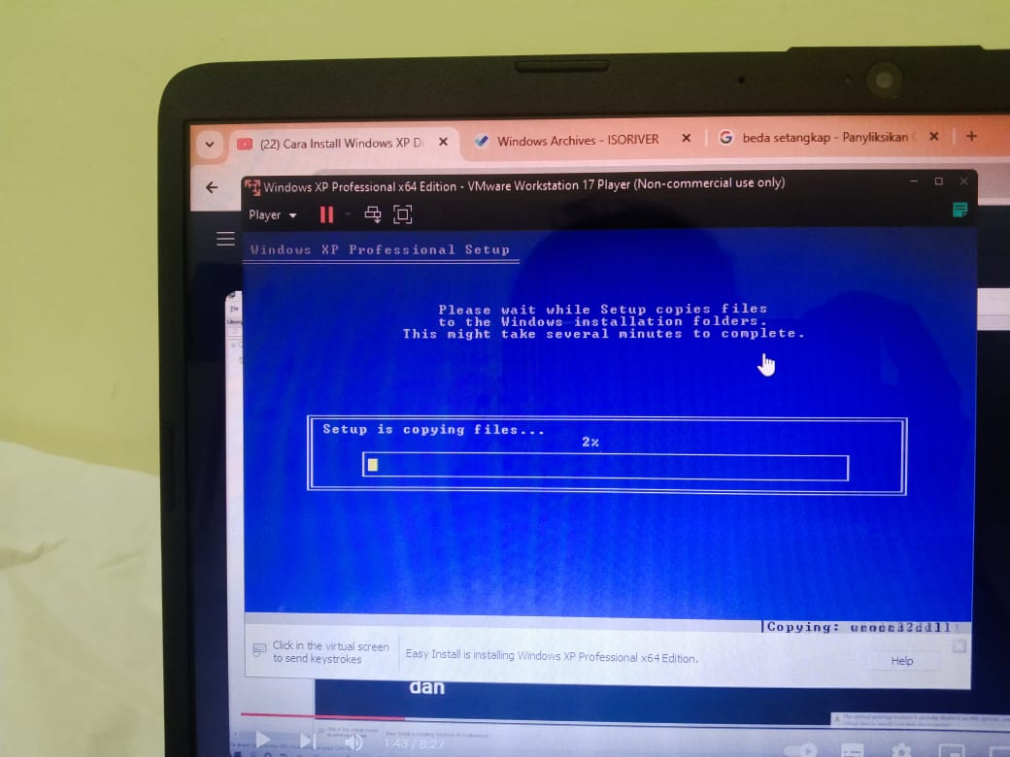 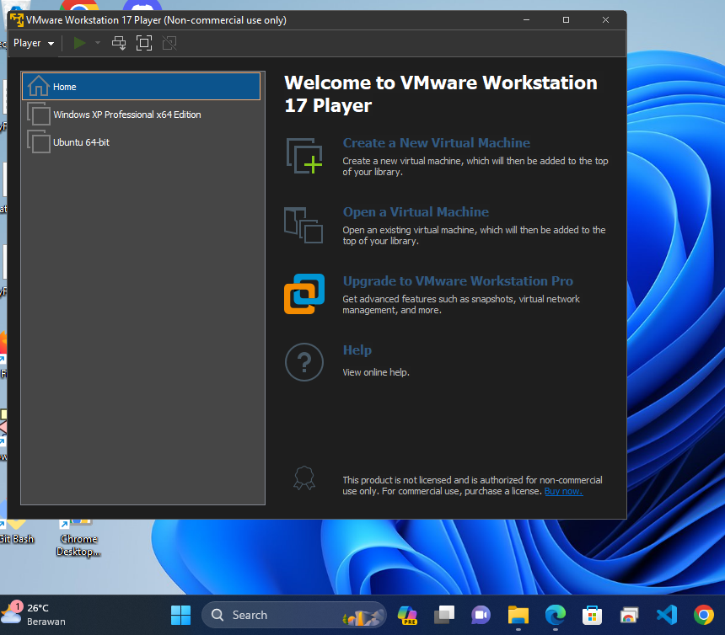 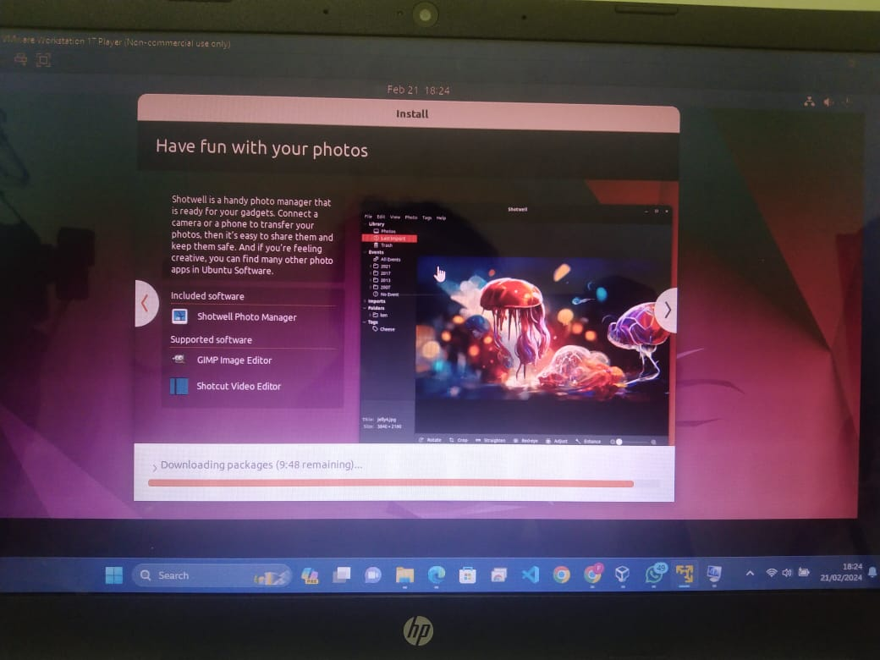



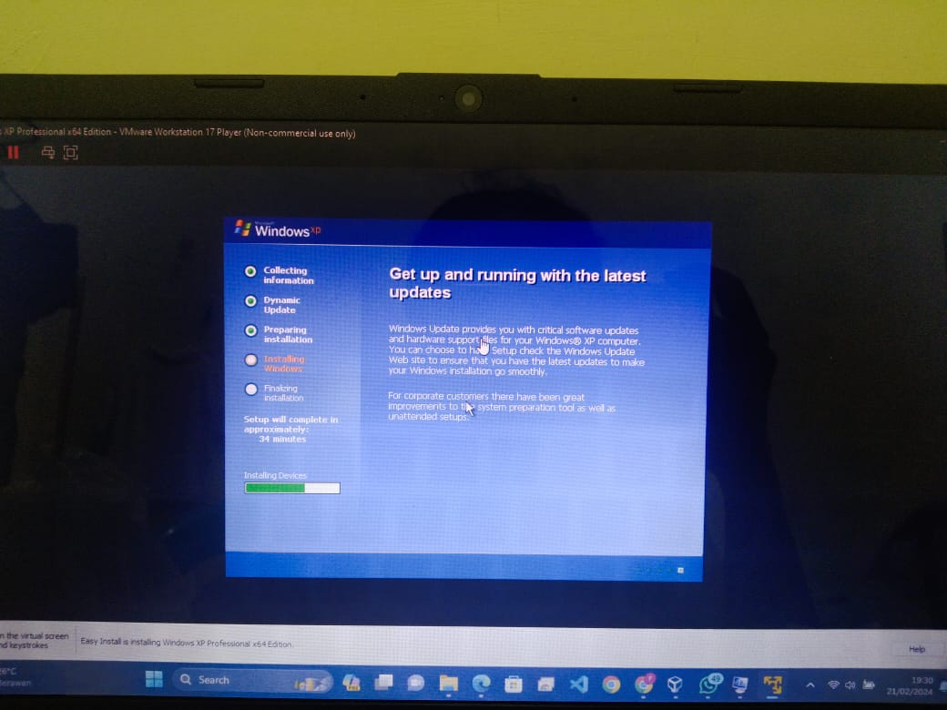

1. Analyze the exercises that have been done.

The exercise I have done today is learning about operating systems, then installing VMware and Linux, then doing practical assignment 1, namely the basic operating system.

1. Provide conclusions from this practicum.

The conclusion of today's practicum is to expand their knowledge and skills in managing and using alternative operating systems and virtualization technology. After installing Linux and Windows on the VMWare application, you know and understand how to install two operating systems at the same time without having to uninstall the previous operating system and without causing interference.